MD. RAQUIBUR RAHMAN 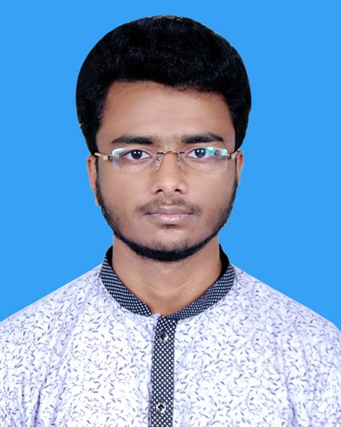TALUKDER

Contact Address

Golden street,Shaymoli,

Dhaka, Bangladesh,

Mobile: **+8801873930506**

+8801705833622

E-mail: [rayhanrt0@gmail.com](mailto:rayhanrt0@gmail.com)

Objectives:

The ICT world is a challenging market makes a best perform. I want to gather knowledge and experience working as Data Entry Operator.

Skills:

Data entry,WordPress,HTML,CSS,

Adobe Photoshop, Adobe Illustrator.

Work experience:

1 year experience as data collector .

OproIT.

Dakhil Examination

Group : Science

Institute : Sarsina Darussunnat Kamil Madrasha.

Result : 4.61 out of (5.00)

Passing year : 2016

**Higher Secondary Certificate**

Group :Science

Institute :FM International College  
Result :4.08 out of (5.00)

Passing year :2018

Personal Information:

Name : Md.Raquibur Rahman Talukder

Father’s Name : Abdus Sattar Talukder

Mother’s Name : Khadiza Begum

Date of Birth : 19/05/2000

Nationality : Bangladesh

Religion : Islam (Sunni)

Marital Status : Unmarried

Gender : Male

Blood Group : O +

Signature